**Question #:** List the features and functionalities of the following SQL platforms:

* MySQL
* PostgreSQL
* Oracle Database
* Microsoft SQL Server

Consider the following aspects of these platforms:

* Data types
* Data manipulation
* Performance
* Security
* Scalability
* Cost

**Solution:**

**MySQL:**

**Data types:** Supports a wide range of data types including numerical, string, date/time, and Boolean.

**Data manipulation:** Provides a comprehensive set of SQL statements for data manipulation including SELECT, INSERT, UPDATE, DELETE, and more.

**Performance**: Known for its high-performance capabilities and scalability, particularly in read-intensive environments.

**Security:** Offers a variety of security features including SSL support, access control, and encryption.

**Scalability:** Supports scalability through various techniques such as sharing, replication, and clustering.

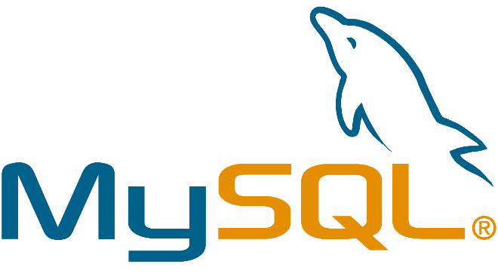**Cost:** MySQL is free and open-source software, with commercial versions and support available for a fee.

**PostgreSQL:**

**Data types:** Supports a wide range of data types including numerical, string, date/time, and Boolean, as well as advanced types like arrays, JSON, and geometric types.

**Data manipulation:** Provides a comprehensive set of SQL statements for data manipulation including SELECT, INSERT, UPDATE, DELETE, and more. Also offers advanced features like triggers, stored procedures, and views.

**Performance:** Known for its stability, reliability, and ability to handle complex workloads, particularly in write-intensive environments.

**Security:** Offers a variety of security features including SSL support, access control, and encryption.

**Scalability:** Supports scalability through various techniques such as sharing, replication, and clustering.

**Cost:** PostgreSQL is free and open-source software, with commercial versions and support available for a fee.

**Oracle Database:**

**Data types:** Supports a wide range of data types including numerical, string, date/time, and Boolean, as well as advanced types like spatial data and XML.

**Data manipulation:** Provides a comprehensive set of SQL statements for data manipulation including SELECT, INSERT, UPDATE, DELETE, and more. Also offers advanced features like triggers, stored procedures, and views.

**Performance:** Known for its high-performance capabilities and ability to handle large and complex workloads.

**Security:** Offers a variety of security features including SSL support, access control, and encryption.

**Scalability:** Supports scalability through various techniques such as partitioning, clustering, and replication.

**Cost:** Oracle Database is proprietary software and can be expensive, with licensing fees based on the number of processors and/or users.

**Microsoft SQL Server:**

**Data types:** Supports a wide range of data types including numerical, string, date/time, and Boolean, as well as advanced types like spatial data and XML.

**Data manipulation:** Provides a comprehensive set of SQL statements for data manipulation including SELECT, INSERT, UPDATE, DELETE, and more. Also offers advanced features like triggers, stored procedures, and views.

**Performance:** Known for its high-performance capabilities and ability to handle large and complex workloads.

**Security:** Offers a variety of security features including SSL support, access control, and encryption.

**Scalability:** Supports scalability through various techniques such as partitioning, clustering, and replication.

**Cost:** Microsoft SQL Server is proprietary software and can be expensive, with licensing fees based on the number of processors and/or users. However, there are also free and lower-cost editions available for smaller workloads.